Answers

The first sound pattern below has been recorded three times using different digital sampling settings.
Recording A
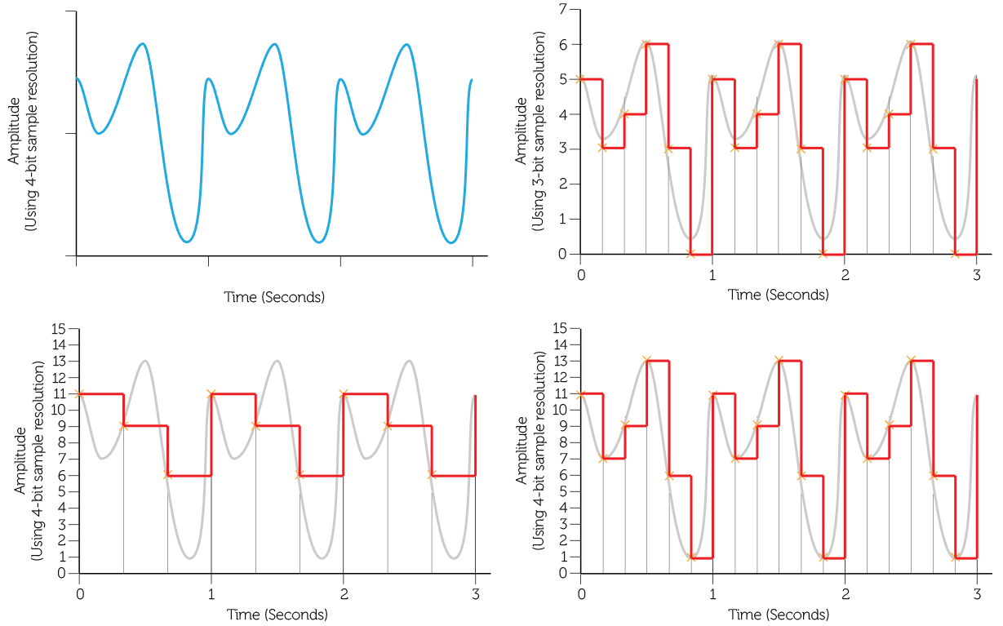
Recording B
Recording C

Calculate the file size of the each of the recordings A to C: (Show your workings) [6]

A: Resolution has 8 points – 0-7. 3 bits per sample required to give a maximum of eight unique sample values.
Frequency is 6hz or 6 times per second over three seconds = 18 sampled points
18 x 3bits = 54bits

Note: This is a fractional sample of a sound wave, with a heavily simplified resolution and sample frequency. In reality, sound would be sampled many thousands of times a second (CD quality is at 44.1kHz or 44,100 samples per second) at a much higher resolution of perhaps 32 bits, (16bits for each stereo channel – Left and Right) producing much larger files! This example, with a sample resolution of only 3 bits per sample, and only six samples over 1 second, amounts to 18bits/s or bits per second. Bits per second is a measurement of recording quality. Even a compressed MP3 file would be recorded at at least 128kbits/s or 128,000bits/s.

B: 16 sampling levels requires 4 bits per sample x 9 samples
9 x 4bits = 36bits

C: 16 sampling levels requires 4 bits per sample x 18 samples
18 x 4bits = 72bits / 8 = 9 Bytes

Allow one mark for each correct answer and an additional mark for the correct method.

Which of the recordings above will be of the highest quality? [1]
Recording C as it has the highest resolution and samples are taken more frequently.

State a device that is used to capture an analogue sound signal. [1]
Microphone.

The length of a recording will heavily influence the size of the sound file.
State two factors other than recording length that determine the file size of a recording. [2]

Sample rate / interval / frequency.
Sample resolution / (audio) bit depth.

A portable sound recorder is used to record an interview.
The recorder uses the following settings:

Frequency: 20 kHz

Resolution: 20 bits

Time: 1 minute 40 seconds
Calculate the file size of the interview in megabytes. [5]

File size = 20 kHz x 20 bits x 100 seconds (1)
File size = 40 000 000 bits (1)
File size = 40 000 000 / 8 = 5 000 000 bytes (1)
File size = 5 000 000 / (1024²) = 4.77 MB (2)
1 mark for each stage in the calculation. Award full marks if the correct answer and unit are given but intermediate workings are not shown. 1 mark is given for the unit (MB/megabytes).

[Total 15 marks]

